Holman Garden Club
Hose End Sprinklers
Equipment
Table cloth and banners for display table
Selection of sprinklers as available in store
Grip and Lock fittings and demonstration piece
Tap timer selection with display mount if available

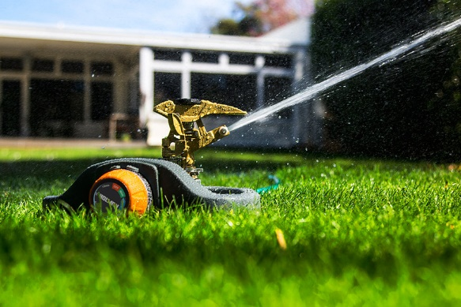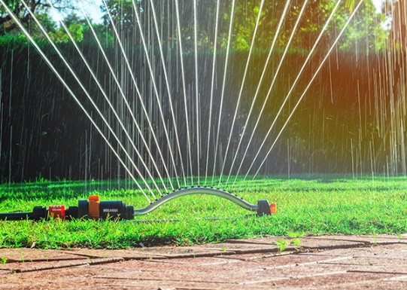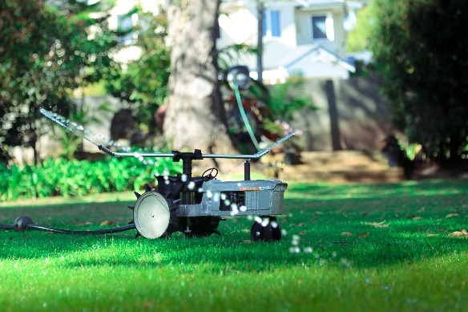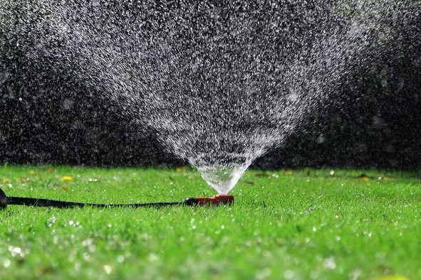
Script
There are many benefits of Hose-End sprinklers
- Easily moved from place to place
- No set up required
- Can be attached to timer for automatic operation
- Packs away for mowing, parties, winter
Droplet size - an important consideration when watering
- Too large and you risk soil erosion from the impacts (that’s why watering cans have roses)
- Too small and you’ll get wind effects and fail to water your chosen area
- Very small (misting) leads to evaporation
Soaker hoses
- No moving parts, no metal parts
- covers rectangle 20m x 6m
- Large particle size – little evaporation or misting
Oscillating sprinklers
- One of the top 10 products in many stores
- For large, rectangular sections of lawn, up to 300m²
- Adjustable left and right
- Quiet, gentle operation
- Large particle size – little evaporation
- Optional timer
Pyramid dome
- No moving parts
- No small restrictions to get blocked – great for dam water
- Circular pattern up to 3m radius (30m²)
Shaker on weighted base
- For low flow applications
- Coverage depends on water pressure
8 Function Sprinkler Spike TWIN PACK
- offers several spray patterns such as Mist and Shower
- Arc selection adjustment to only water the wanted area
- Spike for easy install and movement
- Snap on hose connector for any garden hose
Impact sprinklers
- Tough, robust, reliable
- Adjustable to suit a wide variety of applications
- full and part circle operation with easy arc adjustment
- Distance deflector and pin adjusts from 6m to 12m radius
- Anti-splash back arm to save wasting water
- O-ring seals connection without thread tape
- Screw into a sprinkler base, riser tube or hose end spike
- Metal or plastic
- Bases can have wheels, legs or timers
- Bases and heads sold separately
Adjusting Spray Pattern
- Part Circle Coverage - Push trip lever DOWN then adjust the friction collars
- Full Circle Coverage - Lift the trip lever UP
Adjusting spray distance
- For maximum throw distance with a solid stream of water, wind diffuser pin out
- For a shorter throw distance, screw the diffuser pin into the water stream, this will interrupt the flow causing a mist type spray.
- Deflector Shield: Using the arrows as a guide, turn the distance control knob on top of the sprinkler to either min or max to suit your application.
Travelling Sprinkler Tractor
- For extra-large lawns
- Full circle coverage up to 13.5m diameter
- Travel up to 60m
- Solid metal construction
- Self-propelled 2-speed gearbox
- Travels the path of the hose
Metal Spike sprinkler
- Up to 4m on each side, 2m forward
- For flower beds and borders
Metal Spike bases
- Click into hose-end fitting or poly pipe
- 13 or 19mm
- Strong metal design
- Tees or Elbows
- Can add a variety of sprinkler heads
Sprinkler heads
- Metal half circle spray head
- Metal full circle spray head
- Metal butterfly with metal or plastic spinner
- Metal or Plastic Large butterfly
- Mini-shaker for low pressure applications
With such variety, there is a combination to suit any application
Sprinkler heads also useful for rooftop pvc attachment in fire prone areas.
Companion products
- Retractable Hose reels – avoid tripping, unsightly mess, sun damage and kinking of hose
- Grip and Lock Hose Connectors
- Tap timers – briefly outline range
- O-rings – replace regularly
- Oz Hose
Conclusion / Review
Q & A session
If time permits, move outside to demonstrate some of the key products above in operation. In particular, the oscillating sprinkler, soaker hose, impact sprinkler on base.

